Feature Engineering and Predictive Modeling Report
Introduction
Customer churn prediction is an important application of machine learning that enables organizations to identify customers who are likely to discontinue their services. After completing data cleaning and exploratory data analysis, the next phase of the project focused on feature engineering and predictive modeling. Feature engineering was performed to create meaningful variables that could improve model performance, followed by the development of multiple classification models to predict customer churn. The models were evaluated using standard performance metrics, and SHAP analysis was used to explain the model predictions.
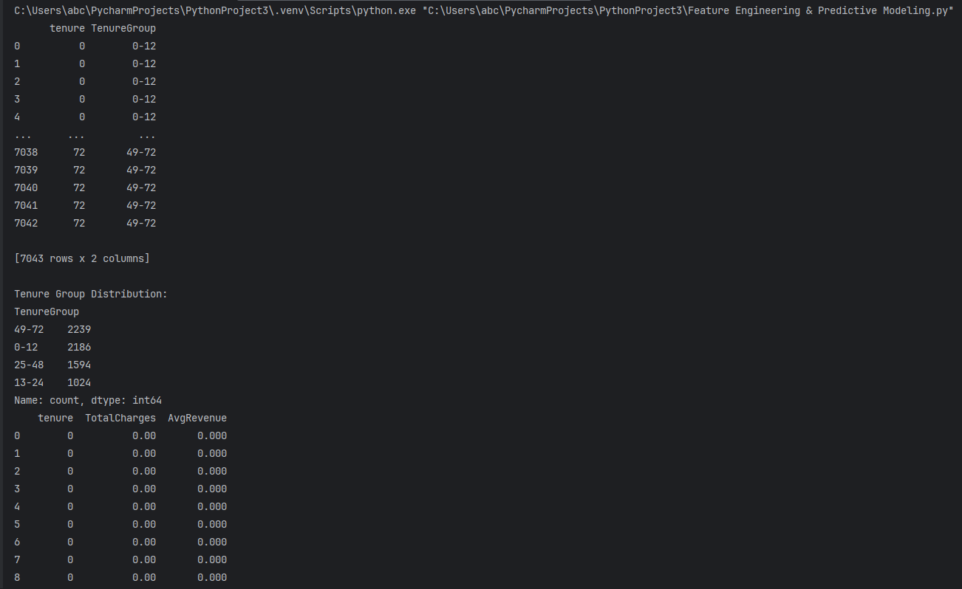

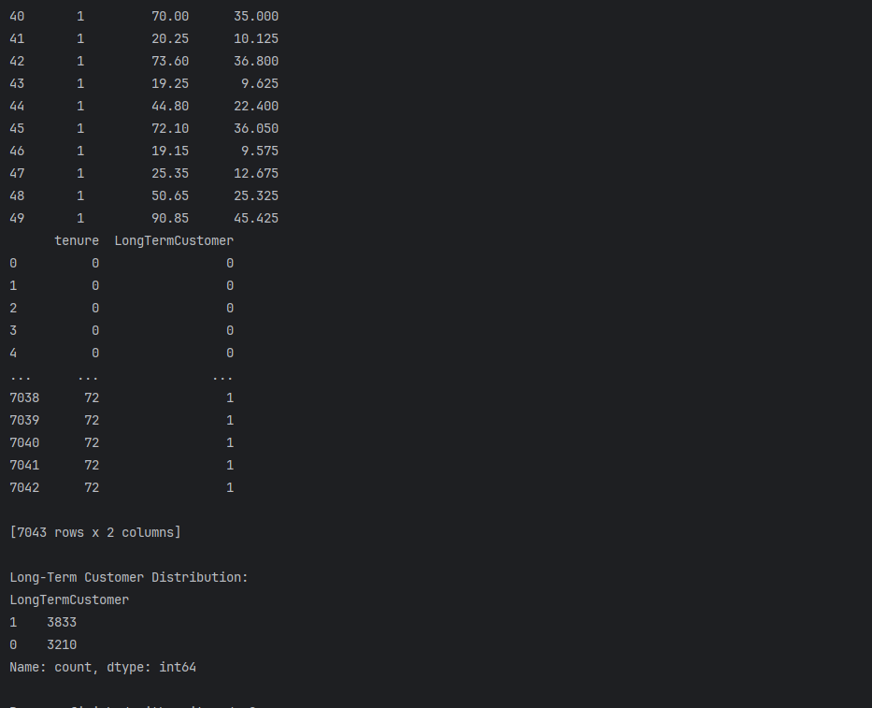

Explanation
During the feature engineering phase, several new variables were created to improve the predictive capability of the machine learning models. The Tenure Group feature categorized customers into four groups (0–12, 13–24, 25–48, and 49–72 months), where the output showed that the highest number of customers (2,239) belonged to the 49–72 months group, followed by 2,186 customers in the 0–12 months group. An Average Revenue Per Month feature was created by dividing the total charges by the customer's tenure plus one, providing an estimate of the average monthly revenue generated by each customer. Additionally, a Long-Term Customer feature was developed by assigning customers with a tenure greater than 24 months a value of 1 and the remaining customers a value of 0. The output indicated that 3,833 customers were classified as long-term customers, while 3,210 were short-term customers. Finally, the customerID column was removed because it is a unique identifier and does not contribute to predicting customer churn.
2.Explanation
The dataset was first prepared for machine learning by converting all categorical variables into numerical values using Label Encoding, ensuring that the algorithms could process the data efficiently. The dataset was then divided into independent features and the target variable, where customer-related attributes were used as input features and Churn was selected as the target variable.
An 80:20 train-test split was performed, resulting in 5,634 records for training and 1,409 records for testing, allowing the models to be trained and evaluated on separate datasets. Three classification models, namely Logistic Regression, Random Forest, and XGBoost, were developed and evaluated using Accuracy, Precision, Recall, F1-score, Confusion Matrix, and Classification Report. Logistic Regression achieved an accuracy of 79.99%, Random Forest achieved 79.49%, while XGBoost achieved the highest accuracy of 80.98%, along with competitive precision, recall, and F1-score values. Based on the overall evaluation metrics, XGBoost demonstrated the best predictive performance among the three models and was therefore selected as the final churn prediction model.
These results indicate that the developed models are capable of effectively identifying customers who are likely to churn and provide a strong foundation for customer retention strategies and the subsequent Customer Lifetime Value (LTV) prediction phase.
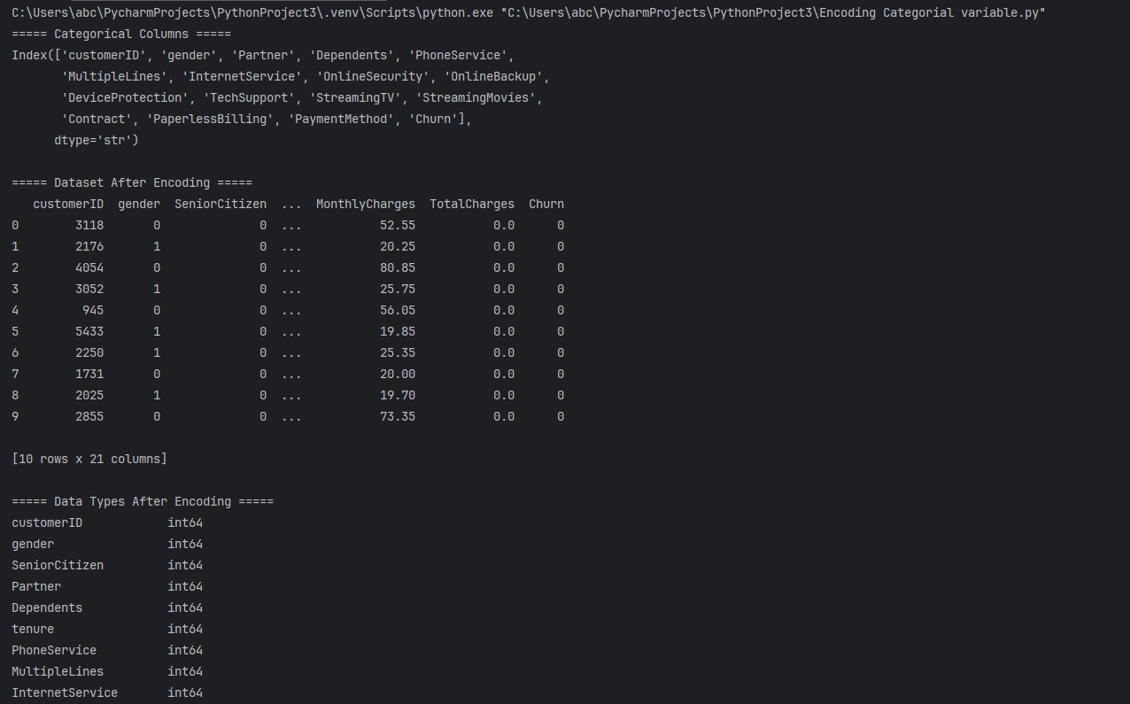
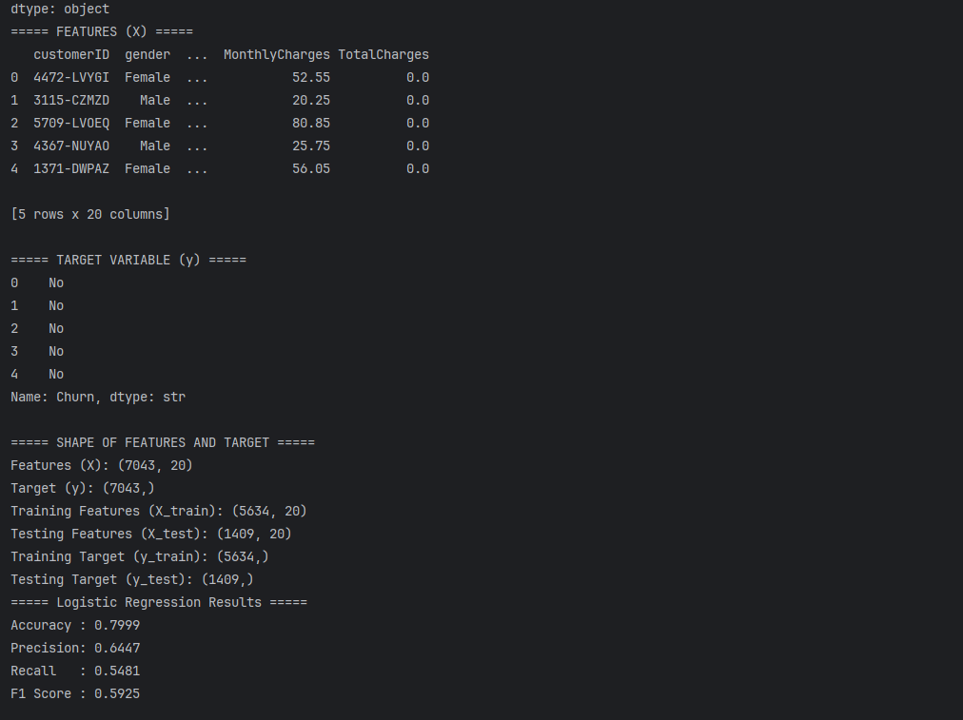
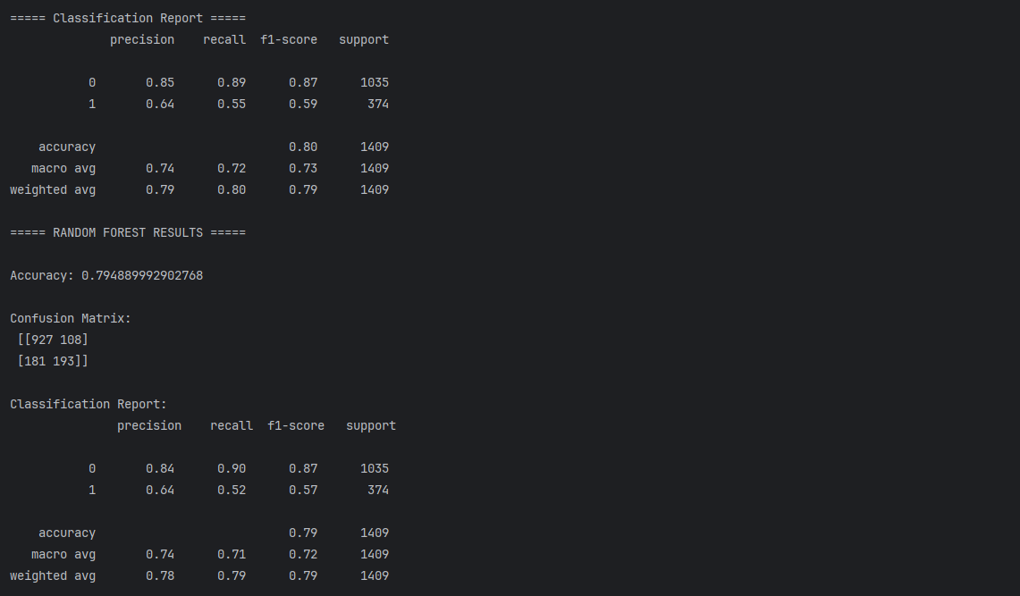
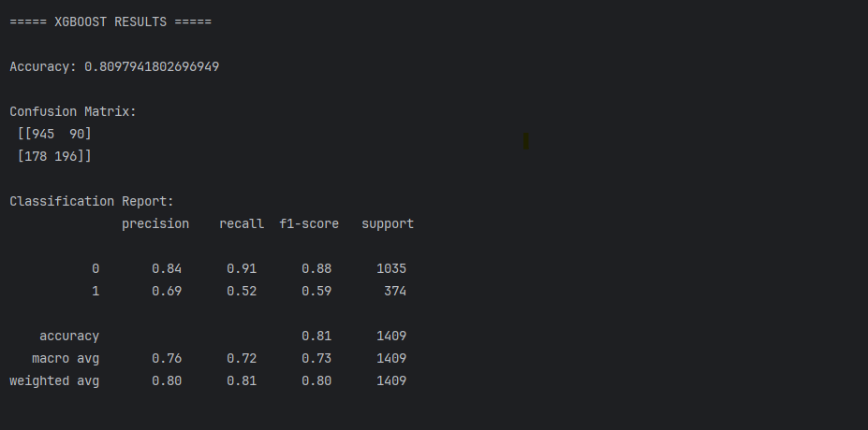
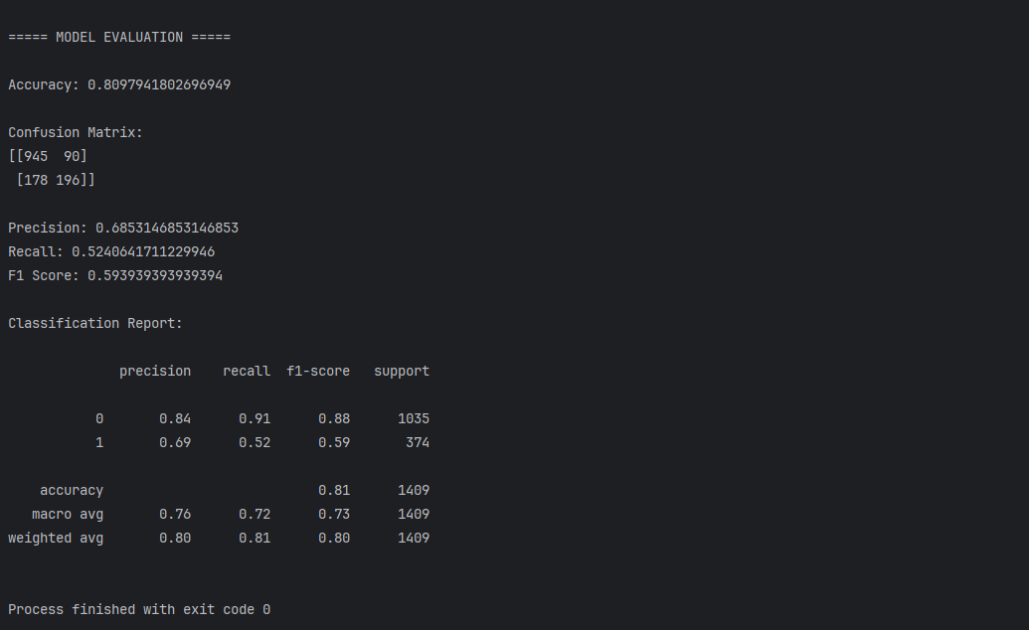
SHAP Analysis
To improve the interpretability of the XGBoost model, SHAP (SHapley Additive exPlanations) was used to identify the contribution of each feature towards customer churn prediction. The SHAP Summary Plot and Feature Importance Bar Plot indicate that Contract is the most influential feature affecting customer churn, followed by Tenure, Monthly Charges, and Total Charges. Customers with month-to-month contracts and shorter tenure have a greater likelihood of churning, whereas customers with longer tenure generally show a lower risk of leaving the company.
Billing-related factors such as monthly and total charges also have a significant impact on customer churn. In addition, service-related features including Online Security, Tech Support, Payment Method, and Internet Service contribute to the model's predictions, while variables such as Phone Service, Device Protection, Dependents, and Streaming TV have comparatively lower importance. Overall, the SHAP analysis provides a clear understanding of the factors influencing customer churn and enhances the transparency of the XGBoost model by explaining how individual features contribute to its predictions.

